Module: Web Design & Development (Y2Sem1)
Worksheet: 1 (Worth 5%) — Due end of Week 5
Stack: HTML, CSS, Bootstrap 5, Express + Handlebars (HBS)
Student: Silvana Pereira da Silva

## Checklist — Task 1 (Apply Bootstrap)

- ☑︎ Bootstrap **navbar** implemented on **all routes**
<!-- Navigation starts -->
<a href="#home" class="logo"> <img src="images/icons_leaf/TheBlueLeafRestaurant_LOGO-Sil.png" width="160" height="59" alt="logoBlueLeaf"> </a> <!--<i class="fas fa-utensils"></i>-->

<nav class="navbar navbar-expand-lg bg-body-tertiary">
<div class="container-fluid">
<button class="navbar-toggler" type="button" data-bs-toggle="collapse" data-bs-target="#navbarNav" aria-controls="navbarNav" aria-expanded="false" aria-label="Toggle navigation">
<span class="navbar-toggler-icon"></span>
</button>
<div class="collapse navbar-collapse" id="navbarNav">
<ul class="navbar-nav">
<li class="nav-item">
<a class="nav-link {{#if state.home}}active{{/if}}" href="/">Home</a>
</li>
<li class="nav-item">
<a class="nav-link {{#if state.about}}active{{/if}}" href="/about">About Us</a>
</li>
<li class="nav-item">
<a class="nav-link {{#if state.gallery}}active{{/if}}" href="/gallery">Gallery</a>
</li>
<li class="nav-item">
<a class="nav-link {{#if state.menu}}active{{/if}}" href="/menu">Menu</a>
</li>
<li class="nav-item">
<a class="nav-link {{#if state.contact}}active{{/if}}" href="/contact">Contact</a>
</li>
<li class="nav-item">
<a class="nav-link {{#if state.booking}}active{{/if}}" href="/booking">Booking</a>
</li>

- ☑︎ Use **`container`** on every page/route
<body>
<!-- Menu starts -->
<div class="container">
<section class="py-5">
<header class="text-center mb-5">
<h1 class="display-6">Menu</h1>
</header>

<!-- Gallery starts -->
<div class="container">
<div class="row">
<div class="col-12">
<figure class="gallery-group">
<h3>Video</h3>
<iframe width="1100" height="515" src="https://www.youtube.com/embed/sTjBt4LsvoE?si=YFmdj7109jiwcZRz" title="YouTube video player" allow="accelerometer; autoplay; clipboard-write; encrypted-media; gyroscope; picture-in-picture; web-share" referrerpolicy="strict-origin-when-cross-origin" allowfullscreen></iframe>
<span class="icon"><i class="fas fa-plus"></i></span>
</figure>
</div>

<body>

<!-- Contact starts -->

<div class="container"><itemscope itemtype="http://schema.org/Restaurant">
<div class="row">

<div class="col-12">
<picture>
<source srcset="images/menupic/atlantic1.jpg" media="(max-width: 576px)">
<source srcset="images/menupic/brownie.jpg" media="(max-width: 768px)">
<img src="images/menupic/cesar1.jpg">
</picture>
</div>

<body>

<!-- Booking starts -->

<div class="container">
<section class="reservation" id="booking">
<header class="reservation-header">
<h2 class="reservation-title">Reservation</h2>
</header>

- ☑︎ Apply grid with **`row`/`col-*`** where there is columnar content
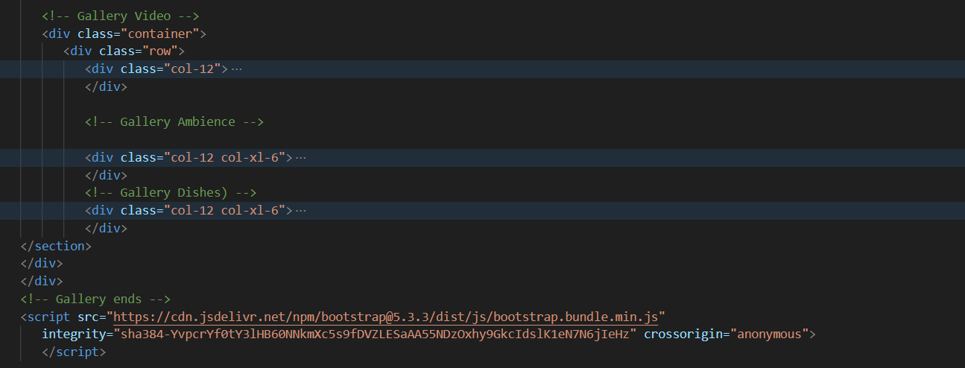

- ☑︎ Buttons use **`btn`** / **`btn-primary`** (or customized)
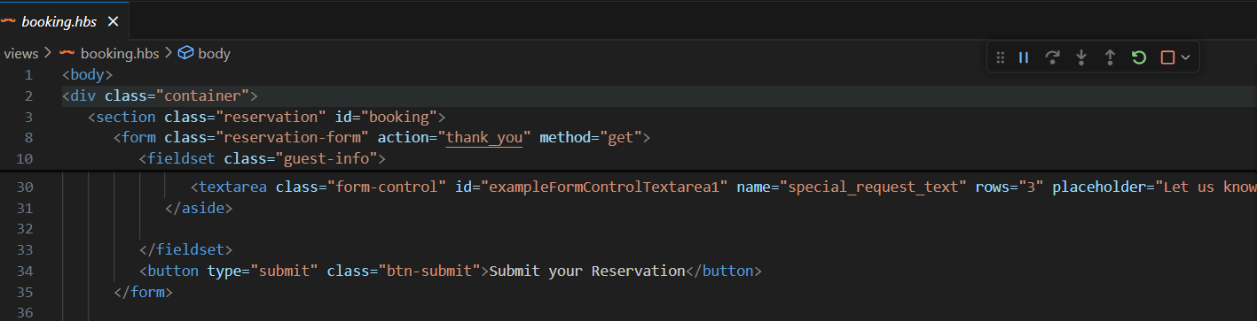

- ☑︎ Forms use **`form-label`**, **`form-control`**, etc.
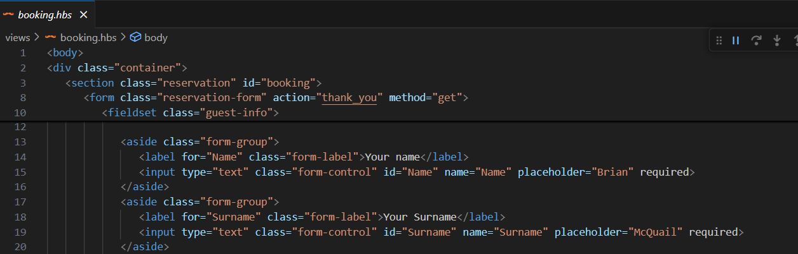

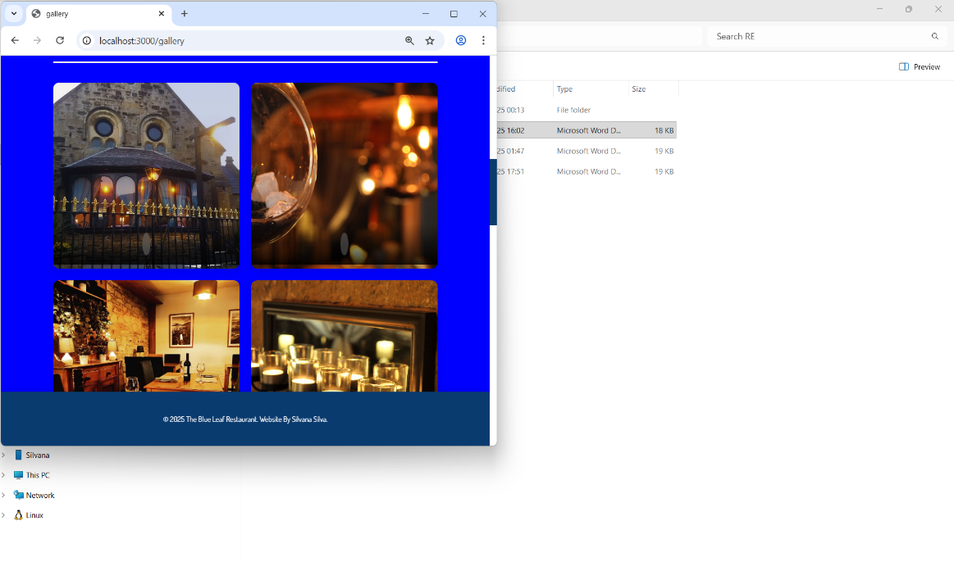
- ☑︎ Images are responsive (**`img-fluid`**)

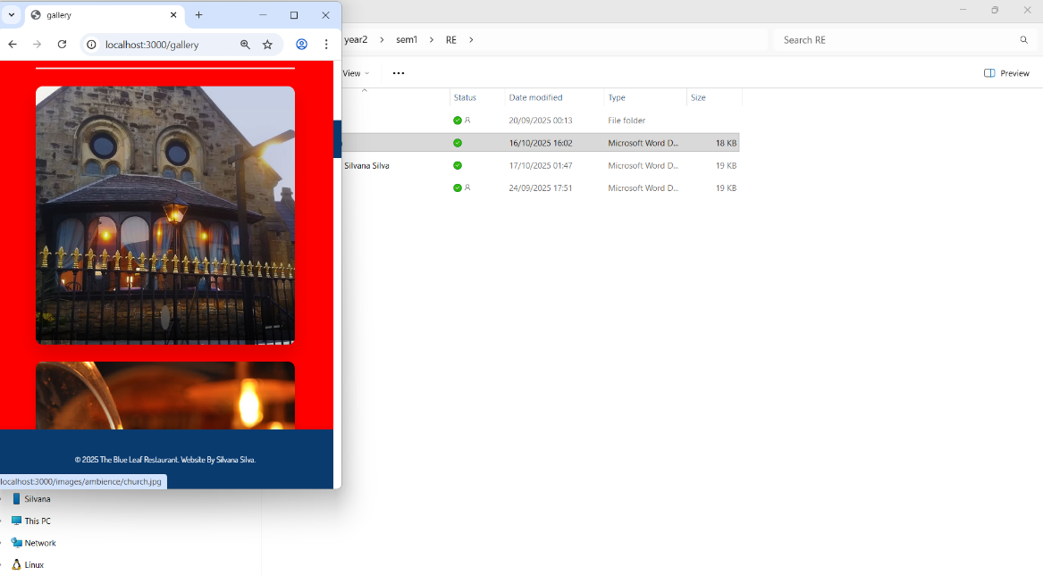

- ☑︎ Spacing via utilities (**`mb-*`**, **`py-*`**, **`g-*`**) instead of custom CSS
<div class="container">
<section class="py-5">
<header class="text-center mb-5">
<h1 class="display-6">Menu</h1>
</header>

<!-- Starters -->
<h2 class="h4-mb-3">Starters</h2>
<div class="row row-cols-1 row-cols-md-2 g-4 mb-5">
<div class="col">
<div class="card border-navy h-100">

- ☑︎ Selective overrides in **`custom.css`** only (avoid `!important`)
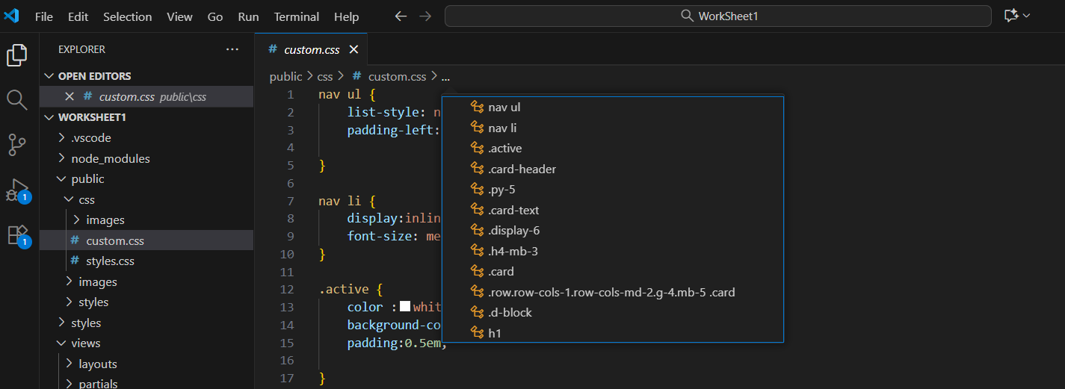

## Checklist — Task 2 (Contact Form using GET)

- ☑︎ Form includes **Name**, **Email**, **Message**
body>
<div class="container">
<section class="reservation" id="booking">
<header class="reservation-header">
<h2 class="reservation-title">Reservation</h2>
</header>

<form class="reservation-form" action="thank_you" method="get">

<fieldset class="guest-info">
<legend>Personal Information</legend>

<aside class="form-group">
<label for="Name" class="form-label">Your name</label>
<input type="text" class="form-control" id="Name" name="Name" placeholder="Brian" required>
</aside>
<aside class="form-group">
<label for="Surname" class="form-label">Your Surname</label>
<input type="text" class="form-control" id="Surname" name="Surname" placeholder="McQuail" required>
</aside>
<aside class="form-group">
<label for="email" class="form-label">Your email</label>
<input type="email" class="form-control" id="email" name="email" placeholder="mcquail@example.com" required>
</aside>

- ☑︎ All fields are **`required`**
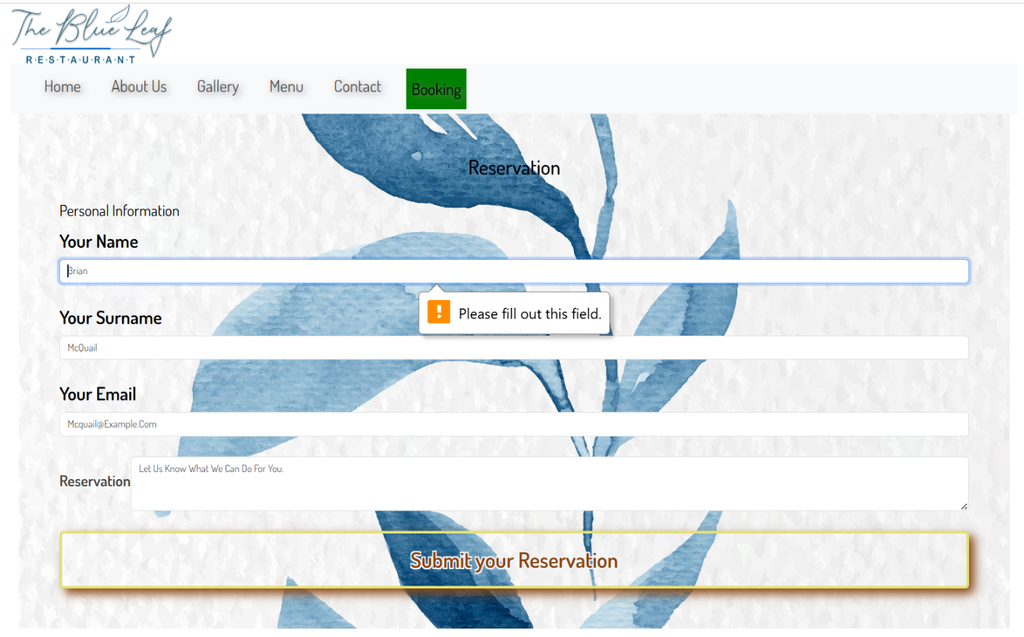

- ☑︎ Form has **`method="get"`** and **`action="/thank-you"`** (or your chosen route)
<div class="container">
<section class="reservation" id="booking">
<header class="reservation-header">
<h2 class="reservation-title">Reservation</h2>
</header>

<form class="reservation-form" action="thank_you" method="get">

- ☑︎ Create **`app.get('/thank-you', …)`** route
// Reservartion
app.get('/booking', (req, res) => {
state={booking:true}
head={title: "Booking", description:"Book a table at The Blue Leaf Restaurant", keywords:"book, reservation, restaurant, food"}
// pass object to to render in "index"
res.render('booking', {state, head});
// send this to terminal where node app is running
console.log('booking')

});

//Thank you
app.get('/thank_you', (req, res) => {
head={title:"Thank you", description:"Thank you for booking", keywords:"thank you, booking, reservation, restaurant"}
formDetails = {userEmail: req.query.email, userName: req.query.Name, userSurname: req.query.Surname,userSpecialRequest:req.query.special_request_text};
res.render('thank_you', { formDetails });
});

- ☑︎ Read submitted values from **`req.query`**
//Thank you
app.get('/thank_you', (req, res) => {
head={title:"Thank you", description:"Thank you for booking", keywords:"thank you, booking, reservation, restaurant"}
formDetails = {userEmail: req.query.email, userName: req.query.Name, userSurname: req.query.Surname,userSpecialRequest:req.query.special_request_text};
res.render('thank_you', { formDetails });
});

- ☑︎ Render **Thank You** view showing the submitted details
<body>
<h1>Thank you</h1>

<p>Thank you for your reservation! We look forward to welcoming you to The Blue Leaf Restaurant.</p>
<p>A confirmation email has been sent to you.</p>
<p>User Name: {{formDetails.userName}}</p>
<p>User Surname: {{formDetails.userSurname}}</p>
<p>User Email: {{formDetails.userEmail}}</p>
<p>User Special Request: {{formDetails.userSpecialRequest}}</p>
<p><a class="btn btn-primary" href="/">Home</a></p>

<script src="https://cdn.jsdelivr.net/npm/bootstrap@5.3.3/dist/js/bootstrap.bundle.min.js" integrity="sha384-YvpcrYf0tY3lHB60NNkmXc5s9fDVZLESaAA55NDzOxhy9GkcIdslK1eN7N6jIeHz" crossorigin="anonymous"> </script>

</body>

- ☑︎ Include **“Return to Home”** link/button on the Thank You page
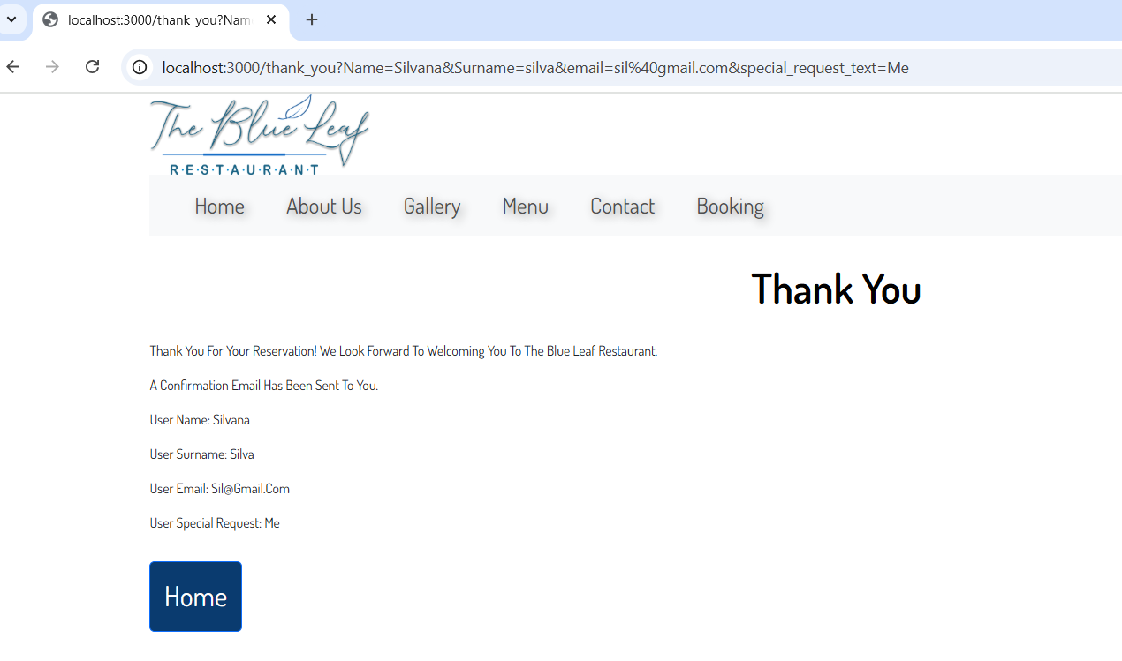

## Checklist — README & Submission

- ☑︎ `README.md` briefly explains what was changed (Task 1 & Task 2)
- ☑︎ Screenshots document from Year 1 module included
- ☑︎ **Exclude `node_modules/`** from the ZIP
- ☑︎ App runs locally (startup instructions in README)

## (Optional) Nice-to-haves

- ☑︎ Active nav link highlights the current route
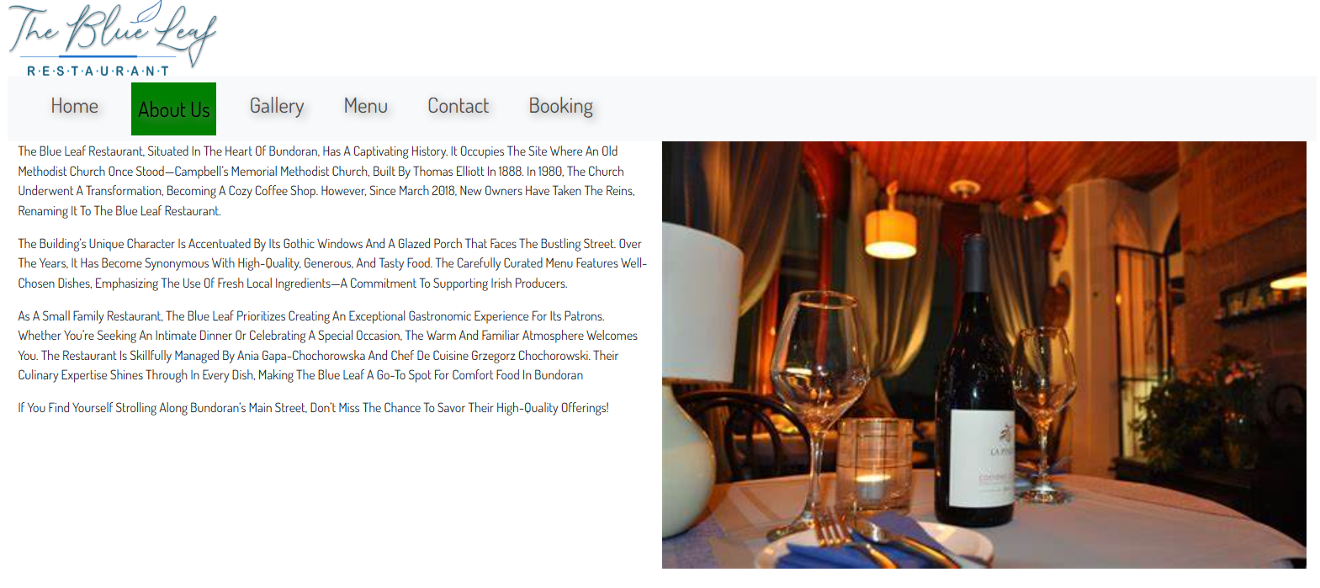
- ☑︎ Basic accessibility: labels tied to inputs, `alt` text on images, keyboard-friendly nav
<figure class="gallery-group">
<h3>Ambience</h3>
<a href="images/ambience/church.jpg" class="box">
<img src="images/ambience/church.jpg" alt="Church interior">
<span class="icon"><i class="fas fa-plus"></i></span>
</a>

<a href="images/ambience/blsaloon1.jpg" class="box">
<img src="images/ambience/blsaloon1.jpg" alt="sitinarea">
<span class="icon"><i class="fas fa-plus"></i></span>
</a>

